Title (Times New Roman,14 pt)

Name Surname (Times New Roman, Bold, 11 pt)
Institute- Department, Post Code, City, Country (Times New Roman, Italic,11 pt)

Brief summary of the study should be written as Times New Roman with 10 font size. Brief summary of the study should be written as Times New Roman with 10 font size. Brief summary of the study should be written as Times New Roman with 10 font size. Brief summary of the study should be written as Times New Roman with 10 font size. Brief summary of the study should be written as Times New Roman with 10 font size. Brief summary of the study should be written as Times New Roman with 10 font size.Brief summary of the study should be written as Times New Roman with 10 font size.

The body of the extended abstract should have a brief introduction, description of the work, highlights of the results and the conclusion of the study [1]. The body of the extended abstract should have a brief introduction, description of the work, highlights of the results and the conclusion of the study. The body of the extended abstract should have a brief introduction, description of the work, highlights of the results and the conclusion of the study.

Table 1: Table title (Times New Roman, italic,10 pt)
Random | sample sample | ramdom sample
sample. | Random sample | Random sample
sample, | Random sample | Random sample
sample, | ramdom sample | Random sample

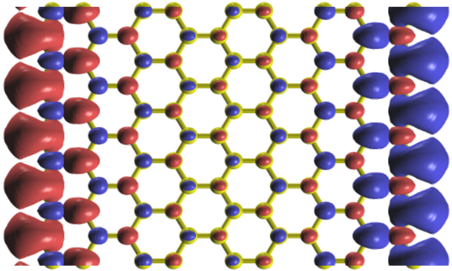

Figure 1: Figure text
(Times New Roman, Italic,10 pt)

The body of the extended abstract should have a brief introduction, description of the work, highlights of the results and the conclusion of the study [2]. The body of the extended abstract should have a brief introduction, description of the work, highlights of the results and the conclusion of the study (Table 1). The body of the extended abstract should have a brief introduction, description of the work, highlights of the results and the conclusion of the study.

References (Times New Roman, Bold,10 pt)

- M. Parstky, A. Basr, F. Benetti, M. Trapso, G. Norosk, “Nonlinear nonrelative example journal and shifts”, Journal of Tranps Triology 393, 1033–1042 (2009).
- A. Diroya, L. Vacsari, A. Bekas, G. Norask, "Infracold Mitroscopy: a sided-screening platform for searching upon infection", AKS Kriyoal Kemiscience, 2 (3), 160–174 (2011).

